Technical Report


Final Assignment
CMP4272
Birmingham City University

Priyangan Vasantharajan
Student ID: 25197298
BSc(Hons) Computer Science with Ai

A1
A1.1 – Search by Name
The search_by_name() method searches the tree for students whose name matches the entered name. The method returns all matching student records.
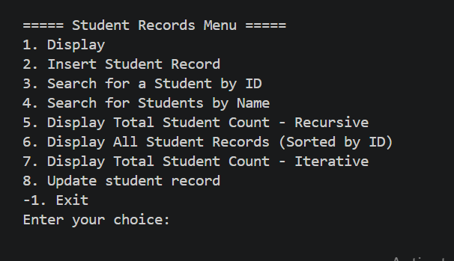
Testing Proof:

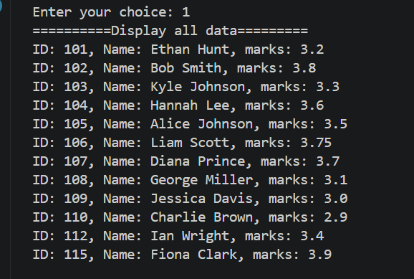

A1.2 – Total Student Count (Recursive)
The total_student_count() method is used to count the total number of students stored in the Binary Search Tree. It uses a recursive approach to visit the nodes in the tree and count each student record. The final count is returned after all the student nodes have been visited.
Testing:
The method was tested using option 5 from the main menu. The output returned a total of 14 students, confirming that the recursive counting method worked successfully.
Testing Proof:
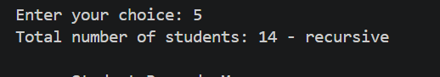
A1.3 – Display Ordered Student Records
The display_ordered() method is used to display all student records in ascending order based on the student ID. It arranges the records by ID and displays the student ID, name and marks in the correct order.
Testing:
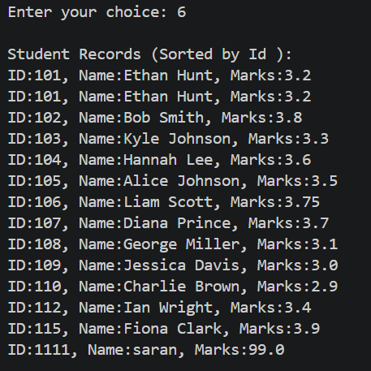
The method was tested using option 6 from the main menu. The output shows that all student records were successfully displayed in ascending order of student ID.

Testing Proof:

A1.4 – Total Student Count (Iterative)
The total_student_count_iter() method is used to count the total number of students in the Binary Search Tree using an iterative approach. It uses a stack to visit each node in the tree and increases the count for every student record found.
Testing:
The method was tested using option 7 from the main menu. The output returned a total of 14 students, showing that the iterative counting method worked correctly.
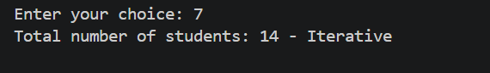

A1.5 – Update Student Record
The update_student_record() method is used to update an existing student record using the student ID. First, the method searches for the given student ID. If the student is found, the user can choose to update either the student’s name or marks. If the student ID does not exist, the system displays a “Student not found” message.
Testing:
The method was tested using option 8 from the main menu. Student ID 115 was selected, and both the name and marks were tested separately. The successful messages confirmed that the student record was updated correctly.

Testing Proof:


A2
A2.1 – Tree: Insert Node
The insert() method is used to add a new student record into the Binary Search Tree. First, a new node is created using the student ID, name and marks. If the tree is empty, the new student becomes the root node.If the tree already contains student records, the new student ID is compared with the current student ID.
If the new ID is smaller, the method moves to the left side of the tree. Otherwise, it moves to the right side. This process continues until an empty position is found, where the new student is inserted.This keeps the student records organised according to their student IDs.
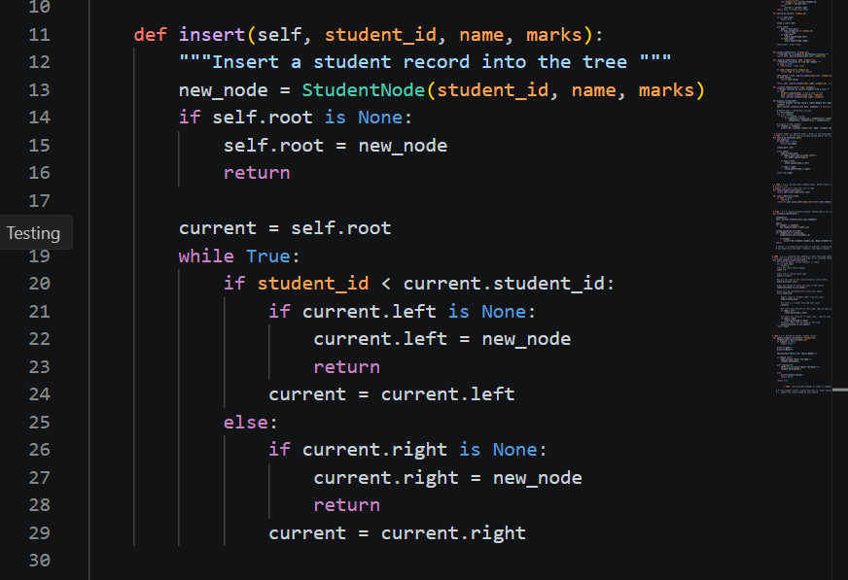

A2.2 – Graph: Create Edge
The add_friendship() method is used to create a friendship connection between two students in the graph. First, the method checks whether both students are already available in the graph. If they are not available, they are added first.After that, each student is added to the other student’s friendship list. This creates a two-way connection between the students. Therefore, if Student A is connected to Student B, Student B is also connected to Student A.
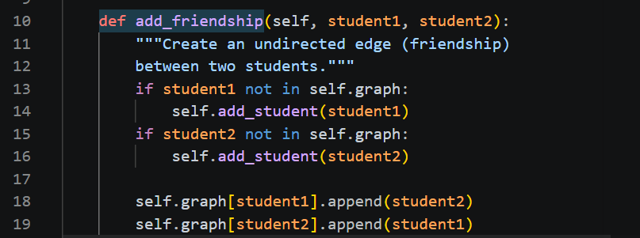

A3.1 – BST Creation Using the Original Insertion Order
The sequence shows how each student ID is inserted into the BST based on its value. Smaller IDs are placed on the left and larger IDs are placed on the right until all 12 student records are inserted.

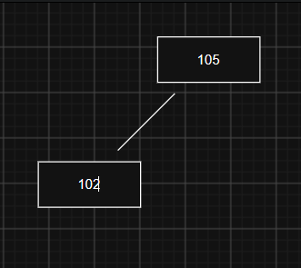


1
2

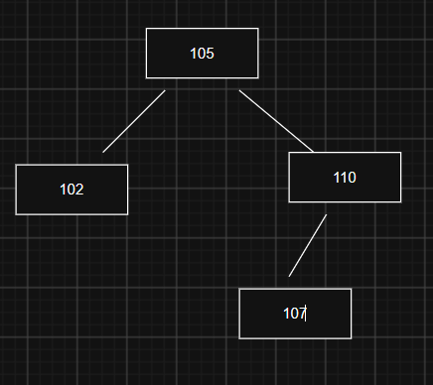
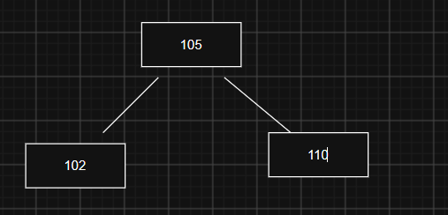
4
3

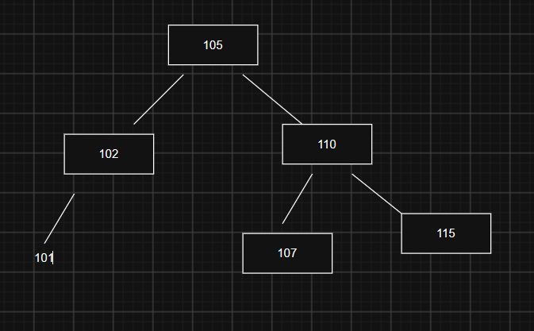
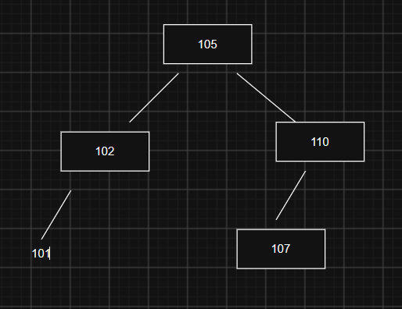
5
6

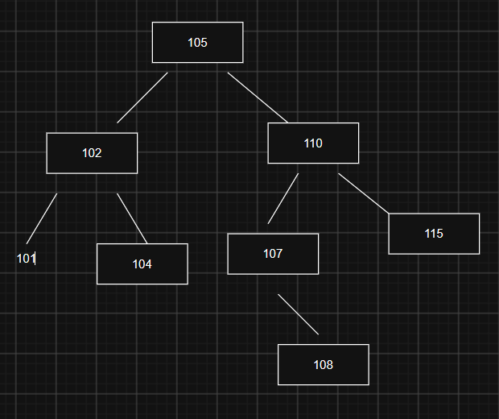
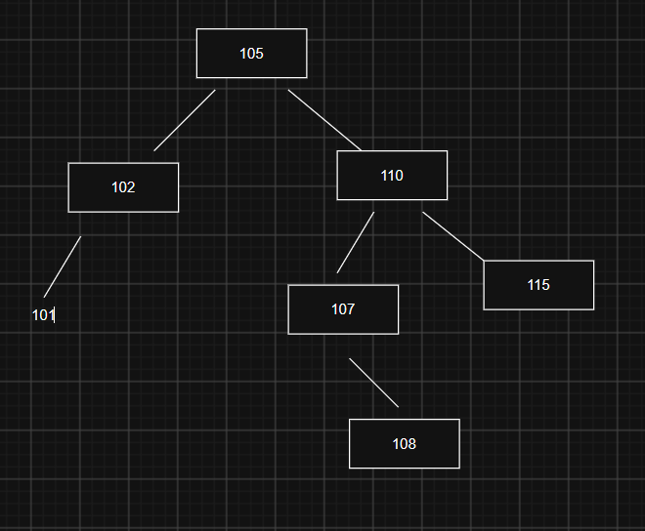

8
7

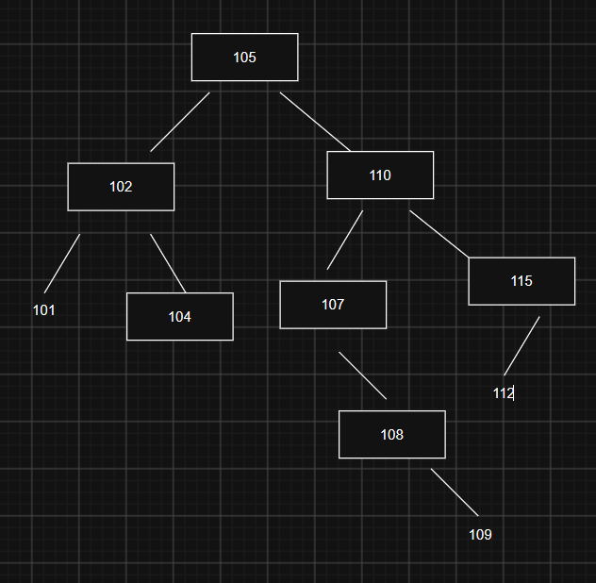
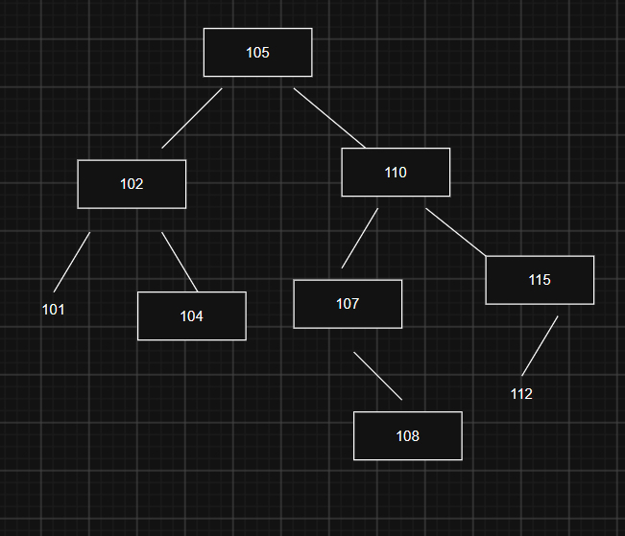

10
9

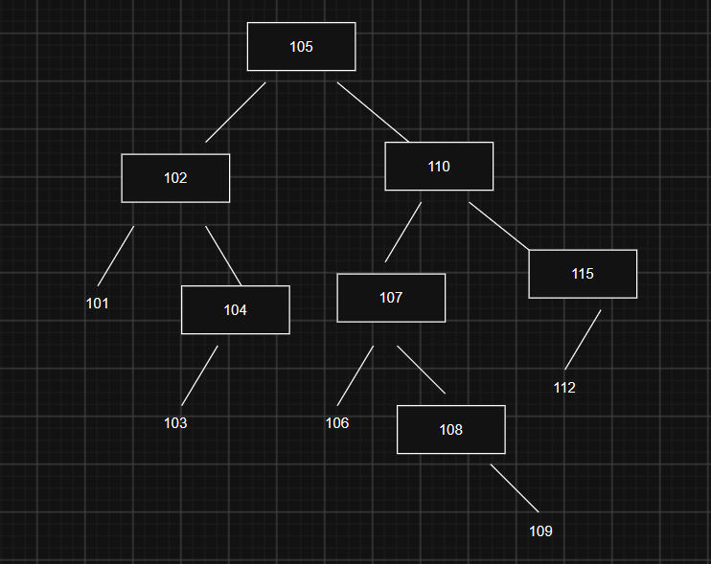
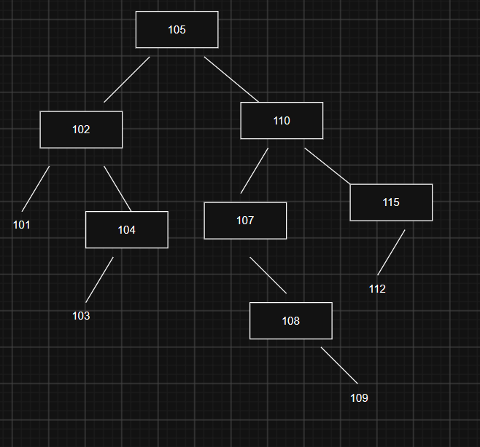
11
12

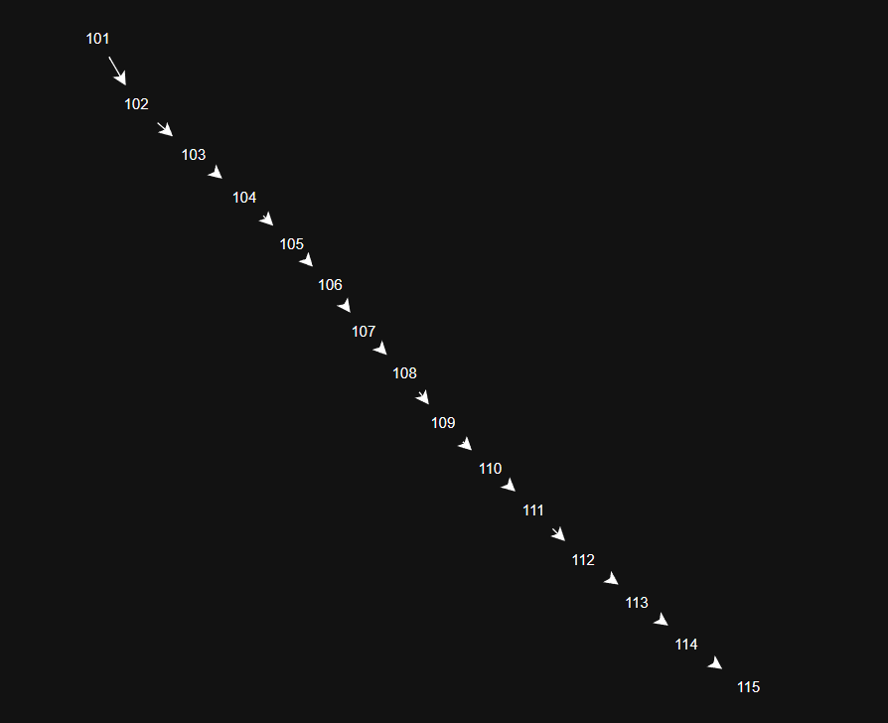
A3.2 = sorted insertion order

B1.1 – Average Execution Times
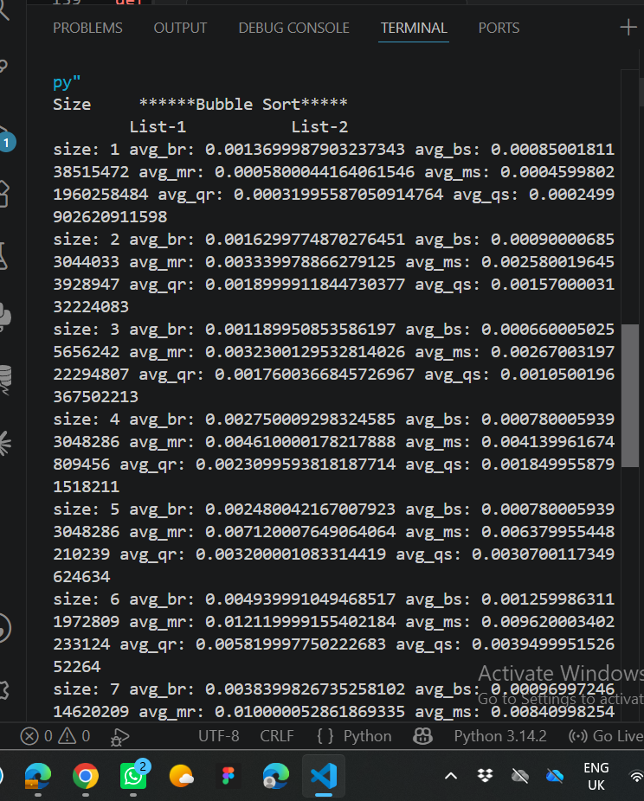
Bubble Sort, Merge Sort and Quick Sort were tested using two different types of input lists. List-1 represents a randomly generated list and List-2 represents a pre-sorted list. Different list sizes were tested and the average execution time was recorded in milliseconds.
Evidence of Termminal:

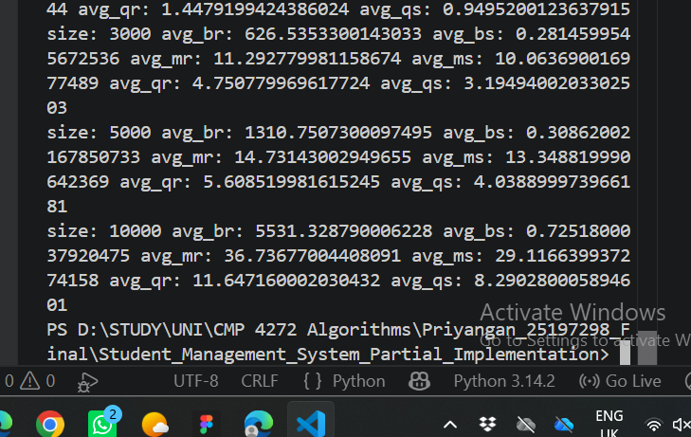

Table-1: Average execution times of Sorting methods
Size | Bubble Sort (List-1) | Bubble Sort (List-2) | Merge Sort  (List-1) | Merge Sort  (List2) | Quick Sort  (List-1) | Quick Sort  (List2)
1 | 0.001 | 0.001 | 0.000 | 0.000 | 0.000 | 0.000
2 | 0.001 | 0.001 | 0.003 | 0.002 | 0.002 | 0.001
3 | 0.002 | 0.001 | 0.004 | 0.004 | 0.003 | 0.001
4 | 0.002 | 0.001 | 0.005 | 0.004 | 0.003 | 0.002
5 | 0.003 | 0.001 | 0.007 | 0.006 | 0.003 | 0.003
10 | 0.007 | 0.001 | 0.016 | 0.013 | 0.009 | 0.006
100 | 0.580 | 0.009 | 0.260 | 0.225 | 0.106 | 0.077
1000 | 64.041 | 0.087 | 3.302 | 3.079 | 1.448 | 0.950
3000 | 626.535 | 0.281 | 11.293 | 10.064 | 4.751 | 3.195
5000 | 1310.751 | 0.309 | 14.731 | 13.349 | 5.609 | 4.039
10000 | 5531.329 | 0.725 | 36.737 | 29.117 | 11.647 | 8.290

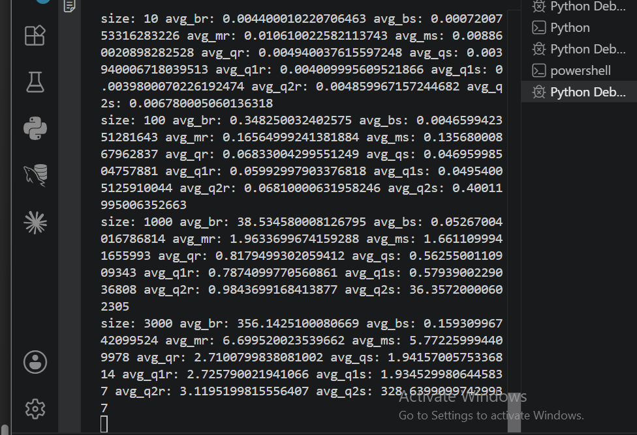
B1.2:Terminal Evidence:

Table-2: Average execution times of Sorting methods
Size | Bubble Sort (List-1) | Bubble Sort (List-2) | Merge Sort  (List-1) | Merge Sort  (List2) | Quick Sort  (List-1) | Quick Sort  (List2) | Quick Sort_v1  (List-1) | Quick Sort_v1  (List2) | Quick Sort_v2  (List-1) | Quick Sort_v2  (List2)
1 | 0.001 | 0.001 | 0.000 | 0.000 | 0.000 | 0.000 | 0.0002 | 0.0001 | 0.0006 | 0.00052
2 | 0.001 | 0.001 | 0.003 | 0.002 | 0.002 | 0.001 | 0.0007 | 0.0006 | 0.0013 | 0.00095
3 | 0.002 | 0.001 | 0.004 | 0.004 | 0.003 | 0.001 | 0.001 | 0.0006 | 0.0017 | 0.0014
4 | 0.002 | 0.001 | 0.005 | 0.004 | 0.003 | 0.002 | 0.001 | 0.001 | 0.0021 | 0.0019
5 | 0.003 | 0.001 | 0.007 | 0.006 | 0.003 | 0.003 | 0.001 | 0.001 | 0.0024 | 0.0025
10 | 0.007 | 0.001 | 0.016 | 0.013 | 0.009 | 0.006 | 0.005 | 0.004 | 0.0069 | 0.0101
100 | 0.580 | 0.009 | 0.260 | 0.225 | 0.106 | 0.077 | 0.06 | 0.050 | 0.0607 | 0.3744
1000 | 64.041 | 0.087 | 3.302 | 3.079 | 1.448 | 0.950 | 0.8 | 0.565 | 0.8753 | 36.9413
3000 | 626.535 | 0.281 | 11.293 | 10.064 | 4.751 | 3.195 | 2.6 | 2.024 | 3.1280 | 323.70
5000 | 1310.751 | 0.309 | 14.731 | 13.349 | 5.609 | 4.039 | 4.5 | 3.232 | 5.3923 | 915.30
10000 | 5531.329 | 0.725 | 36.737 | 29.117 | 11.647 | 8.290 | 9.6 | 6.851 | 11.9435 | 3783.96
B1.3 – Performance Comparison of Sorting Algorithms

The results in Table-2 show that the performance of the sorting algorithms changes depending on the size and arrangement of the input data. Bubble Sort, Merge Sort, Quick Sort and the two modified versions of Quick Sort were compared using random and pre-sorted lists.
Bubble Sort performed well for very small lists, but its execution time increased significantly when the size of the random list increased. For example, with 10,000 random elements, Bubble Sort took around 4120.91 ms. However, its performance was much faster with the pre-sorted list. This shows that Bubble Sort becomes inefficient for large random datasets.
Merge Sort showed more consistent performance for both random and pre-sorted lists. At 10,000 elements, it took around 25.92 ms for the random list and 22.59 ms for the pre-sorted list. Compared with Bubble Sort, the increase in execution time was much smaller as the input size increased.
Quick Sort Version 2 showed a clear difference between random and pre-sorted input. For 10,000 random elements, it took around 11.94 ms, but for the pre-sorted list it increased significantly to around 3783.96 ms. This shows that the performance of Quick Sort can be strongly affected by the way the pivot is selected and the arrangement of the input data.
Theoretical and Practical Performance
The theoretical time complexity helps to explain the results from the practical testing. Bubble Sort can have a time complexity of O(n²), which explains why its execution time increased significantly for large random lists. Merge Sort has a time complexity of O(n log n), so it showed more stable performance when the input size increased.
Quick Sort normally performs efficiently when the pivot divides the data into balanced parts. However, its performance can become O(n²) when the partitions are highly unbalanced. This can be seen clearly in Quick Sort Version 2, where the execution time increased significantly for the pre-sorted list.
From these results, there is no single sorting method that performs the same for every type of input. The experiment shows that the choice of algorithm, pivot selection and input arrangement can have a significant effect on execution time. For larger datasets in this experiment, Merge Sort, the original Quick Sort and Quick Sort Version 1 were more efficient than Bubble Sort, while Quick Sort Version 2 was strongly affected by pre-sorted input.

B2 – Graph Representation and Performance Analysis

The student friendship system uses a graph to store students and their friendships. Each student has a list of friends. This representation is suitable because it only stores the friendships that actually exist.
Adding a new friendship is simple because the student can be added to the other student’s friend list. Checking whether two students are friends requires searching the friend list.
Another option is an adjacency matrix. It can check a friendship very quickly, but it uses more memory because space is needed for every possible connection. Therefore, the current list-based representation is more suitable when students have only a few friendships. An adjacency matrix would be more suitable for a small graph with many friendships.

B3 – Analysis of Searching Algorithms

The search() method searches for a student using the student ID. It compares the ID with the current node. If the ID is smaller, it moves to the left side of the tree. If the ID is larger, it moves to the right side. Therefore, it can find a student without checking every record.
The locate_student() method works differently. It searches through the tree using recursion. It checks the current node first, then the left side and finally the right side. Because of this, it may need to check many students before finding the correct student.
When searching for student IDs 101 and 115, the search() method follows the correct path based on the ID values. The locate_student() method may visit more nodes because it does not use the ordering of the BST.
For a balanced tree, the average time complexity of search() is O(log n). In the worst case, it can become O(n). The time complexity of locate_student() is O(n) because it may need to check all the nodes.Therefore, the search() method is generally more efficient for finding a student by ID.

